# Superstore Sales Queries

Q.1 List the top 10 orders with the highest sales from the order_breakdown table.

Query:

select * from order_breakdown

order by Sales DESC limit 10;

Output:

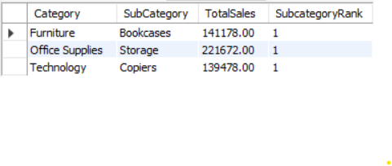

Q.2 Show the number of orders for each product category in the order_breakdown table.

Query:

select count(*) as orders,

category from order_breakdown

group by category;

Output:

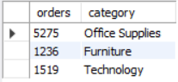

Q.3 Find the total profit for each sub-category in the order_breakdown table.

Query:

select sum(CAST(REPLACE(Profit, '$', '') AS DECIMAL(10, 2))) as profit,

SubCategory from order_breakdown

group by SubCategory;

Output:

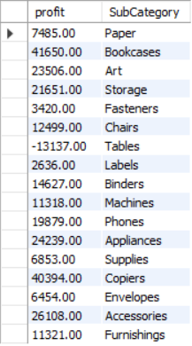

Q.4 Identify the customer with the highest total sales across all orders.

Query:

SELECT ssd.CustomerName,

SUM(cast(replace(ob.sales,'$','') as decimal(10,2))) AS total_sales

FROM superstore_data ssd

JOIN order_breakdown ob ON ssd.OrderID = ob.OrderID

GROUP BY ssd.CustomerName

ORDER BY total_sales DESC limit 1;

Output:



Q.5 Find the month with the highest average sales in the order_breakdown table.

Query:

select month(ssd.ShipDate) as month_name,

avg(cast(replace(ob.Sales,'$','') as decimal(10,2)))

as avg_sales from

superstore_data ssd join order_breakdown ob

on ssd.OrderID = ob.OrderID

group by month_name order by avg_sales DESC limit 1;

Output:



Q.6 Find out the average quantity ordered by customers whose first name starts with an alphabet 's'?

Query:

select avg(ob.Quantity) as avg_quantity

from order_breakdown ob join superstore_data ssd

on ob.OrderID = ssd.OrderID

where left(ssd.CustomerName, 1) = 's';

Output:



Q.7 Find out how many new customers were acquired in the year 2014?

Query:

SELECT COUNT(*) As NumberOfNewCustomers FROM (

SELECT CustomerName, MIN(Year(OrderDate)) AS FirstOrderDate

from superstore_data

GROUP BY CustomerName

Having year(MIN(OrderDate)) = 2014 ) AS CustWithFirstOrder2014;

Output:

Q.8 Calculate the percentage of total profit contributed by each sub-category to the overall profit.

Query:

Select SubCategory, SUM(CAST(REPLACE(Profit, '$', '') AS DECIMAL(10, 2)))

As SubCategoryProfit,

round(SUM(CAST(REPLACE(Profit, '$', '') AS DECIMAL(10, 2)))/(Select SUM(CAST(REPLACE(Profit, '$', '') AS DECIMAL(10, 2)))

FROM order_breakdown),3) * 100 AS PercentageOfTotalContribution

FROM order_breakdown

Group By SubCategory;

Output:

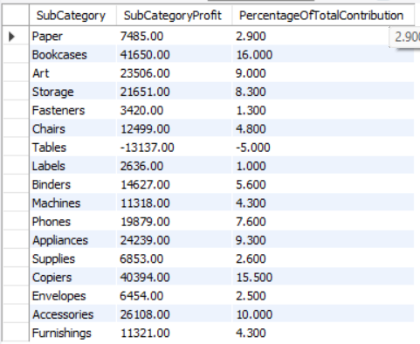

Q.9 Find the average sales per customer, considering only customers who have made more than one order.

Query:

WITH CustomerAvgSales AS(

SELECT CustomerName, COUNT(DISTINCT ssd.OrderID) As NumberOfOrders,

AVG(cast(replace(Sales,'$','') as decimal(10,2))) AS AvgSales

FROM superstore_data ssd

JOIN order_breakdown ob

ON ssd.OrderID = ob.OrderID

GROUP BY CustomerName

)

SELECT CustomerName, AvgSales

FROM CustomerAvgSales

WHERE NumberOfOrders > 1;

Q.10 Identify the top-performing subcategory in each category based on total sales. Include the sub-category name, total sales, and a ranking of sub-category within each category.

Query:

WITH topsubcategory AS(

SELECT Category, SubCategory, SUM(cast(replace(Sales,'$','') as decimal(10,2))) as TotalSales,

RANK() OVER(PARTITION BY Category ORDER BY SUM(cast(replace(Sales,'$','') as decimal(10,2))) DESC)

AS SubcategoryRank

FROM order_breakdown

Group By Category, SubCategory

)

SELECT *

FROM topsubcategory

WHERE SubcategoryRank = 1;

Output:

